HHACA September 2016
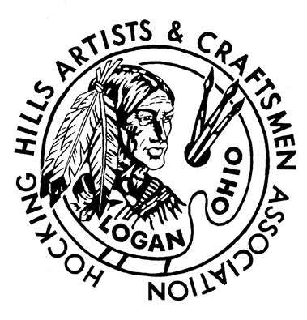

Committee News
Marketplace: No report.
Fall Show: The Show Committee asked everyone who has not yet signed up for the Fall Show to do so ASAP. Also encourage non-members who would be a good addition to apply as well. Application forms can be found on our webpage hhaca.com. We always have a free raffle drawing, and Nick Delmatto has contributed one of his lovely glass pieces. Thank you Nick.
Jury: No report.
Bylaws: Our bylaws revision was approved, and we can move forward with establishing the Advisory Board and the Standard Operations procedures.
Member Services: No report.
Advertising: Flyers for our Fall Show are available at the Visitor’s Center. Please pick them up and share. Audrey will bring to the meeting a limited supply of color posters to be posted at important locations.
Audrey has asked that anyone who has photos of the 2015 Fall Show email those photos to Gretchen Gregory at gretchengregory717@yahoo.com.
Audrey has also asked that you email to Gretchen info about you and your art… What is your art? • How long have you been making it? • Where have you been featured? • A special, fun fact about you or your art. • Your website and/or Facebook page. • Photos of your artwork. Gretchen will feature artists on our Facebook page leading up to the Fall Show.
Spirit will be doing an interview for the Logan paper.
Kay Wilson made arrangements with Brown Funeral to feature an ad for our Fall Show in place of their regular ad in the Logan paper.

Greetings from the President & Executive Committee
Thank you for your willingness to work on a committee, make signs, and distribute flyers or posters! Our Fall Show will be a better success if we individually promote and tell our friends about the show. If you are able to assist Audrey’s or Spirit’s committees, I am sure they can use your skills and talents, and they will greatly appreciate the help.
The HHACA members extend our condolences and sympathies to Jane Pope who very recently lost her husband. Jane, we appreciate you for all the support you give the Marketplace.
The bylaws revision passed by the 2/3 majority of members, and we now need to nominate and fill at least 2 At Large Member positions on the HHACA Board of Directors that is charged with developing a long range vision plan as well as a financial budge each year. I hope to have the election of Board Members in November when we elect the new President and new Treasurer.
If we complete the annual audit by then, we can forecast and budget for 2017 at the Board of Directors meeting this fall. If you have questions about this, please refer to the revised bylaws or contact one of the officers.
See you at the show.

To Do List

Farmers Market
Contact Janet Bowers

Upcoming Events
Foothills Art Festival near Jackson Oct. 14, 15 & 16. Early bird registration was Sept. 2, but you may still be able to participate. This is an exhibit where you can sell your work or just display. foothills@markayjackson.org.
The Bowen House offered us the opportunity to present our work in a show in Feb. You can display 3 or more pieces. If you would like to participate, please contact Spirit Williams.
Midnight at Moonville is a new event at the Moonville Tunnel Oct. 15. The event will include art/craft vendors, regional cuisine, acoustic music, historical presentations and storytelling, and demonstrations of paranormal investigation techniques. Caleb Appleman at 740-596-5033.
Wheat Ridge Olde Thyme Herb Fair & Harvest Celebration Oct. 7, 8 & 9 in West Union, Ohio. Contact Kim Erwin at 937-544-8252.

Facebook & Webpage News
Post your art and art activities on our Facebook page. Facebook.com/hhaca.
PLEASE SEND YOUR BIO AND PHOTO SO YOUR INFO CAN BE INCLUDED ON OUR WEBPAGE. hhaca.com

Food for Thought
“A work of art is above all an adventure of the mind.” Eugene Lonesco.

Attachments
Agenda, Flyer/Poster

Members who plan to participate in the Fall Show need to put one piece of their art at the Welcome Center bookcase display advertising the show.
Flyers for our Fall Show are available at the visitor’s center. Please pick them up and share.
Audrey has also asked that you email to Gretchen info about you and your art… What is your art? How long have you been making it? Where have you been featured? A special, fun fact about you or your art. Your website and/or Facebook page. Photos of your artwork. Gretchen will regularly feature artists on our Facebook page leading up to the Fall Show.

Marketplace
No news for September.

Programs/Demonstrations
September – Betty Ranck & Jennifer Calvin. October – WE NEED VOLUNTEERS.

Snacks
September – Robin Balthaser & Suzanne Hiser. October – Spirit Williams & Helen Bratka.

Library Display
September - Members who plan to participate in the Fall Show need to put one piece of art in the Logan Library display case to advertise the show. October – Vickie Estell & Jane Pope.

2016 Meeting Dates
09/12, 10/10, 11/07, 12/05

